Zphisher Tool
- Objective:
To test phishing awareness and defenses by simulating phishing pages with ZPhisher, helping identify user vulnerabilities, improve security training, and strengthen protection against real phishing attacks.
- Overview:
ZPhisher is an open-source phishing tool that creates fake login pages of popular websites to simulate phishing attacks. It is mainly used in ethical hacking and training to test how users respond to phishing attempts and to evaluate security awareness.
- Step-By-Step:
Step 1: Run git clone https://github.com/htr-tech/zphisher.git
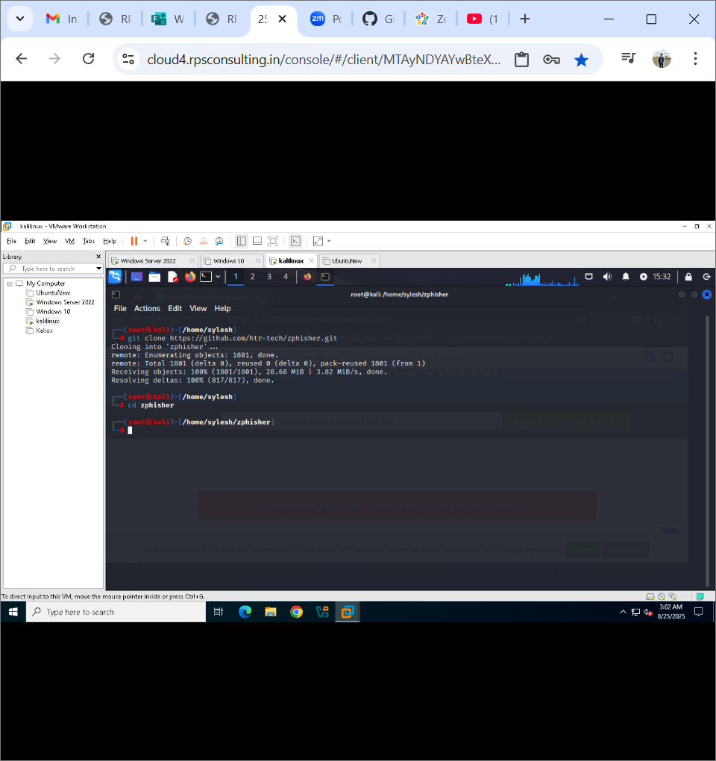

Step 2: Run CD zphisher to reach directory & Run ls command to see all files
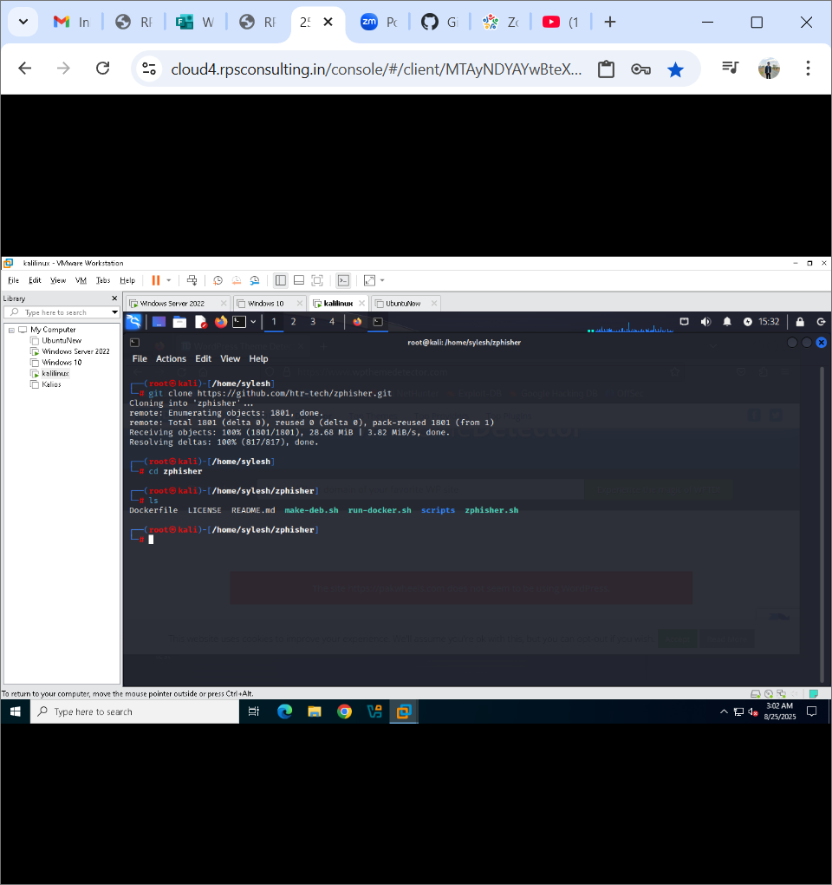
Step 3: Run bash zphisher.sh command to run the tool
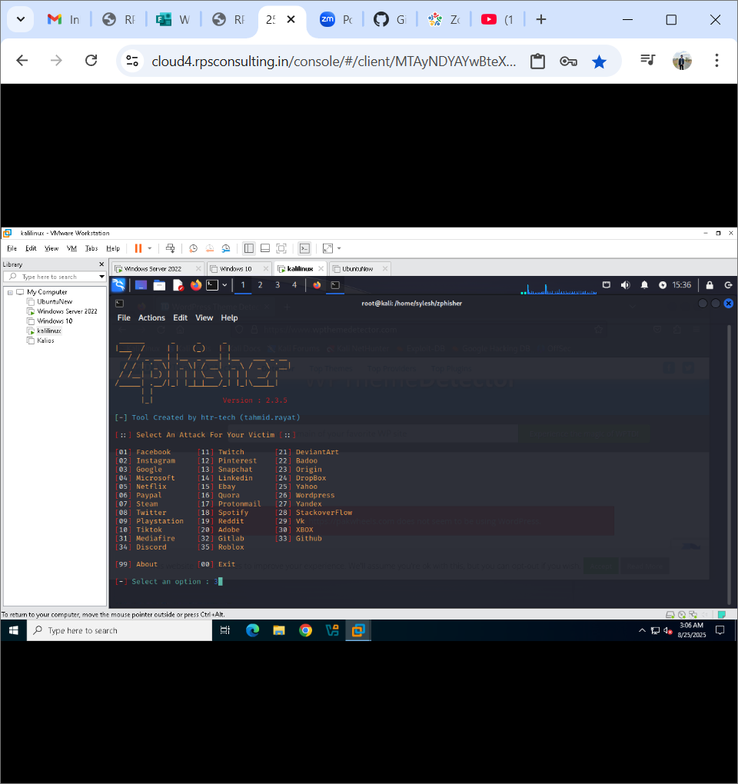
Step 4: Select the website which you want to make a fake login page, in this lab we will do Instagram fake login page.
Press 2 for Instagram

Step 5: Press 1 for Traditional Login Page
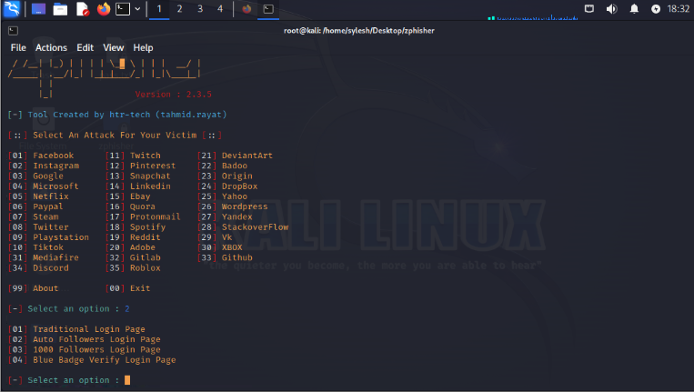

Step 6: Press 2 to use cloud fared as a hosting server & Press N and don’t select custom port
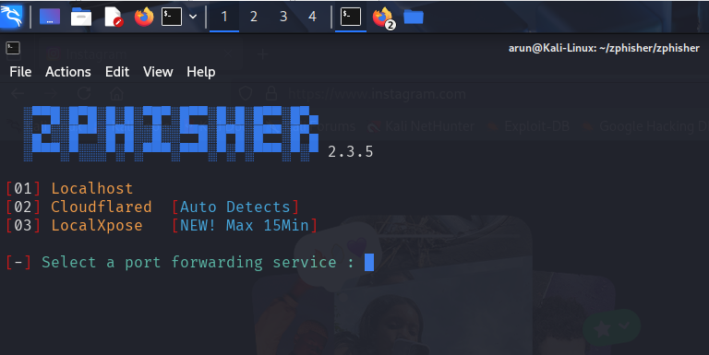

Step 7: copy the given url and send to target person and ask to login
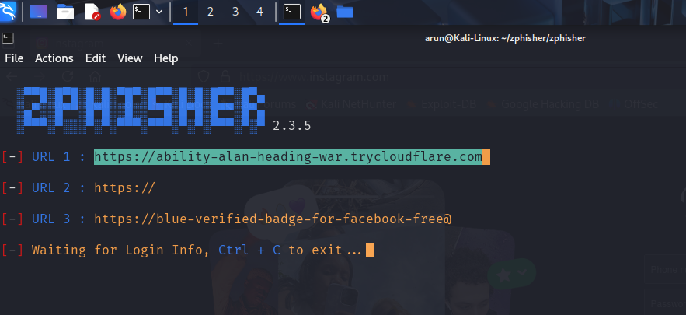
Step 8: Type Credentials
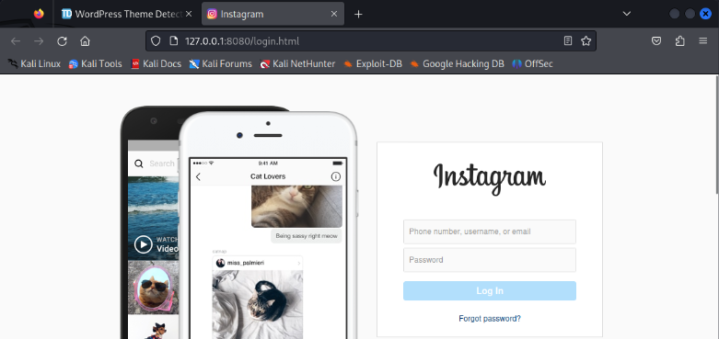
Step 9: Now you can see username and password.
